

**2014 – 15 Growth Goals Dashboard Testing**

# Objective

Setting reasonable but challenging goals for scholar academic growth ensures that scholars, teachers, and leaders understand what level of performance is expected by the end of a school year. These growth goals are one component of the Rewarding Teaching Excellence performance pay program at Uplift Education.

The Data Team created a flexible system to record goals and track progress toward them over the year for every teacher across the network. In some cases, however, changes to rosters will create mismatches between the scholars, tests, or test subjects used to calculate growth goal attainment. **We can ensure goal calculations are accurate by having instructors confirm the system is pulling in the correct scholar, test, and subject data for their performance goals.**

This aid will walk you through the process of confirming your growth goal data. Please read through the following questions and answers to ensure you understand some of the complications of this process.

# Walkthrough

To verify your goals, make sure the outcomes you specified in your goal form in **Section 1** match the posttests, subjects, and/or grade levels displayed in **Section 2.**

Ensure **Section 3** includes all scholars you serve *who were in your class as of 10/31/14.* Therefore, 10/31/14 is our “snapshot date.” Scholars who arrived after this date, or left before this date, should not be included in **Section 3**. Instead, they will appear in **Section 4**.

Two ‘Tabs’:

1. **Growth Goal Dashboard** – used to check your growth goals data
2. **Verification** – a form to confirm your data, or report problems

**Section 3 Scholar Growth Goal Details**

Displays individual scholars’ scores for fall tests, also called pretests, as well as the goal scores to be attained on the spring posttest. **Section 3 is the exact list of scholar goals we will use to process your goal attainment.**

*Note: Pretests may be different from posttests. In those cases, we have a documented linkage from the pretest to the posttest.*

**Section 2 Assessment/Subject Scholar Count**

Displays the test and subject combinations you are accountable for, as well as the number of scholars associated with each

*Example: Looking at Goal 1, my goal is tied to 63 scholars in 9th grade and 16 scholars in 10th grade, who will all be taking the Geometry Uplift EOC.*

**Section 1 Goal Form Data**

Displays the scholar outcome goals you entered in the beginning-of-the-year goal setting process.

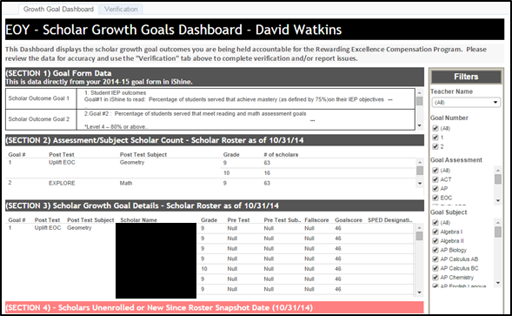

# Questions and Answers

*Q: How long is this going to take?*

A: Unless something is horribly wrong, **this process should take you no more than 10 minutes**. If you think something is horribly wrong, we would prefer you reach out to us directly so we can problem solve. No one should ever be in the position of entering more than a few scholar ID numbers into the verification form – if you think you’re in this situation, please contact us at [data@uplifteducation.org](mailto:data@uplifteducation.org) and we will work with you.

*Q: I don’t know scholar ID numbers. Where are they?*

A: You can look up scholar ID numbers by searching for a scholar in iShine. On the top right of iShine, change the dropdown that reads “This Site: iShine” to “Students,” then type the scholar’s name in the search box.



Click the search button.

*Q: Am I accountable for scholars who recently joined my class?*

A: No. Your roster was frozen on 10/31/14 to determine which scholar growth goals you are accountable for. Scholars who left before this date, or arrived after it, should not be in **Section 3** of your dashboard. **Section 3** is the exact list of goal scores and scholars we will use to process your goal attainment.

*Q: My scholars take Explore/PLAN/ACT and in some cases the goal score is below the fall score! Why?*

A: If a scholar earned a high enough score on one of these tests, we cannot reasonably set a higher goal for their annual growth. In these cases, we use the minimum score associated with the 99th percentile for that test and subject as the goal score.

*Q: My scholars are taking IB, DORA, DOMA, or iReady. Where are the pretests and goal scores?*

A: We do not receive any data from these assessments until the end of the year, so we are not able to provide the pretest or goal scores. IB goals will be calculated based on the midyear assessment results, which we receive along with the end-of-year data. DORA, DOMA, and iReady goals were set by the scholar’s SPED team, and we will calculate these goals as soon as we receive results.

*Q: I work with scholars categorized as SPED. What’s different for me?*

A: SPED Coordinators and Teachers worked to identify their scholars served and modified their growth goals if applicable. If a scholar is included on a roster received from a SPED teacher, they will have the “SPED” designation in **Section 3** which means the SPED and General Education Teacher are held accountable for the modified goal. If a scholar’s growth goal is modified, it will be less rigorous than the Uplift Growth Goal previously assigned. These modified goals usually take the form of an alternate test, such as iReady, or a percentage of the Uplift growth goal.

*Q: I am an interventionist or aide. What’s different for me?*

A: Interventionists, aides, and resident teachers were asked to provide a roster of scholars served. The scholars included on these rosters are the scholars that you are held accountable for. If a roster was not provided, we used the PowerSchool roster if applicable. If neither a roster was provided nor were you assigned to rosters in PowerSchool, your data will not be present because we have no way of identifying the scholars you serve.